1. The source file provided is called MutiCore_Assgnmt1.java

This program makes use of a configuration file called resources.properties (.properties is the file extension)

The program can be run by just double clicking the MutiCore_Assgnmt1.bat file provided.

2. Before running the bat file, the configuration properties file and the source java file, both need to be in the same directory as the bat file.

3. The configuration file is as shown below.

*delay_mean=30*

*no_threads=4*

*no_runs=1000*

The delay_mean (0 to 100) and no_threads (1 to 8) can be varied to check for different system loads and contention scenarios.

Below is one sample execution for reference:

Double click the bat file to run the program.

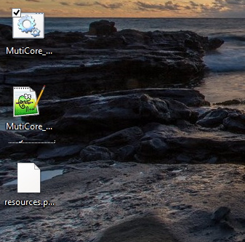

A cmd prompt window will open where the output will be displayed.

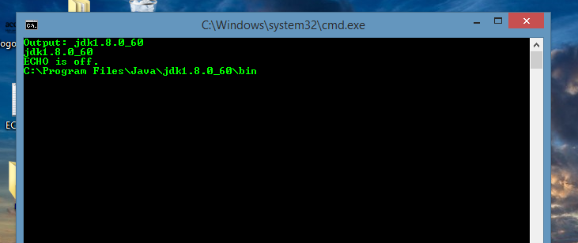

For the first run, it may take a few seconds for the output to be displayed as it is compiling the program and generating the class files namely MutiCore_Assgnmt1.class and Lock.class as shown below.

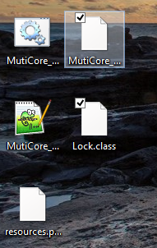

Please wait for the program to finish and reach the last line where you will find the value for the counter (Counter 4000) and the total time (Difference 8378ms) that the program ran for. Here, as shown, the program tool 8 secs to complete for 4 threads with each thread entering critical section 1000 times. (See configuration file); hence the counter value 4*1000=4000. Similarly, the program can be run for other values by editing the configuration file and verified.

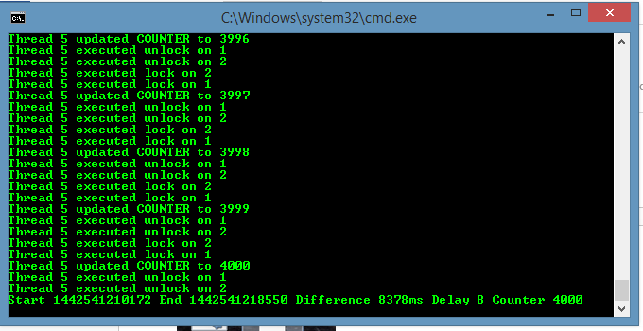

Note: For higher values of inter-request delay and number of threads, the program may take longer time. For example, on some machines, 8 threads for 1000 CS entries and inter request delay of 100 time units took up to 2 mins. The run times may vary depending on the current load on the machine.